Biographies of Consultant

Md. Nurul M Chowdhury, MBA, CPP

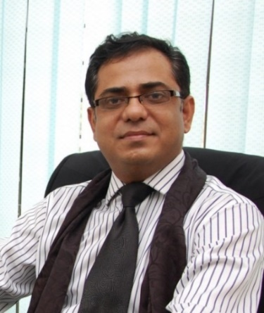

Personal Details

Hometown: Kulaura, Moulvibazar. Was born in 01 Apr 1970.

Father: Late Abdul Muktadir Chowdhury (Jubed Chowdhury) an organizer during liberation war, was at Dharmanargar India with his uncle Barrister Muntaquim Chowdhury MNA, (Barrister Chowdhury was later member of constitution writing team and ambassador to Japan and Germany)

Siblings: Brother Emadul Mannan Chowdhury and Rashidul Mannan Chowdhury both are NRBs staying in UK and USA.

Civ Education: MBA on Human Resource from BRAC University

Political view: Nil.

Social Activities: Involved with local school, mosque and village development works.

Military Career

Commissioned with: 24th BMA Long Course in 1991 and voluntarily resigned in 2004.

Military Courses: OW (B+Y+), BCC (B+) YOinf (AY+B+) JCSC (B+) Junior Command Course India (Qual) PPCC (Qual)

Served in: 19 E Bengal, 18 E Bengal, 26 E Bengal, 4 E Bengal, GSO 3 (ops) 72 Inf Bde.

Served as Instr: Tac Wg SI&T and Pl and Term Commander BMA.

Corporate Career:

Served as:

Director Aegis Ltd (a sister concern of SQUARE Group) from dec 2004 – 2010

Managing Director Avant-Garde Alliance Ltd. 2010 - 2013

Managing Director of –SecurityLink Ltd. 2013-2018

Lead Consultant Thirdeye Risk Consulting (a consultancy firm developing side by side)

Security Training

Certified Protection Professional from ASIS international USA which is the most recognized cert in the world. Member of ASIS since 2009.

Trained by ARC UK

Managed Guarding of following Companies:
- Square group all concerns.
- GrameenPhone
- Apollo Hospital
- North East Medical Collage
- Prothom Alo
- UNDP
- World Bank
- Care International
- ETV
- Desh TV
- NTV
- H&M
- BGMEA
- Many garments.

Did Consultancy for:
- Square Group
- Lafarge Surma Cement
- KAFCO
- AFD
- Dhaka Stock Ex
- GrameenPhone
- The Palace
- The City Bank

Implemented complex Security Technology Projects for
- Grameen Phone Surveillance project
- NTMC

ECA

Authored 2 books on poetry

Editor of two books

Worked as Researchers in Liberation war project by Bangladesh Army 2000 -2004

Currently researching on liberation war on sector 4 area and writing a book on industrial security.

